**Ideation Phase**

**Define the Problem Statements**

|  |  |
| --- | --- |
| Date | 26 June 2025 |
| Team ID | LTVIP2025TMID59506 |
| Project Name | ShopEZ:One-Stop Shop for Online Purchases |
| Maximum Marks | 2 Marks |

**Customer Problem Statement Template:**

Users often face difficulties finding reliable, locally sourced products online through a simple, secure, and convenient shopping experience, leading to frustration with cluttered interfaces, limited product variety, and lack of real-time order updates.

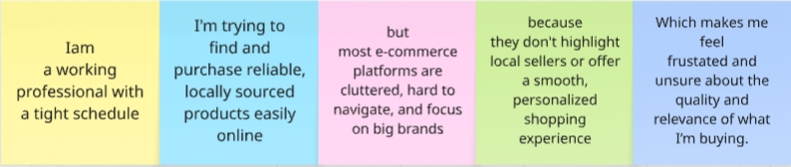

**Seller Problem Statement Template:**

Small shopkeepers struggle to sell online due to limited technical skills, high setup costs, and complex platforms. They lack access to simple, affordable tools tailored to their needs, making it hard to reach digital customers. This leaves them feeling excluded, overwhelmed, and unable to grow in the competitive online market.

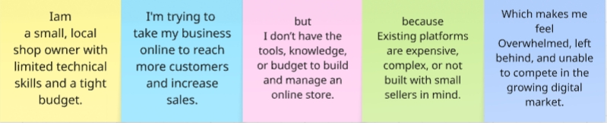

|  |  |  |  |  |  |
| --- | --- | --- | --- | --- | --- |
| **Problem Statement (PS)** | **I am** | **I’m trying to** | **But** | **Because** | **Which makes me feel** |
| PS-1 | a working professional with a tight schedule | find and purchase reliable, locally sourced products online with ease. | most e-commerce platforms are cluttered, promote big brands, and lack local options. | they don’t prioritize local sellers or offer a personalized, simplified shopping experience. | frustrated, overlooked, and unsure about the quality and relevance of what I’m buying. |
| PS-2 | a shopkeeper trying to increase my sales despite huge competition | sell my products online and reach more customers beyond my local area. | i don’t have the technical skills or budget to build and manage an online store. | most e-commerce platforms are expensive, complex, or not designed for small sellers. | left out, overwhelmed, and unable to compete in the digital market. |